# The Analysis Report of Majors and Occupations Preference of 2025 DSE Students

**Kiangsu-Chekiang College**

The following summary report presents the major findings extracted from the survey results collected by Kiangsu-Chekiang College, including students’ major and occupation preferences, the influence of STEM education and Greater Bay Area (GBA) development on their preferences, and students' approaches to stress management. (Total respondents: 53)

* **Majors Preference**

|  |  |  |  |
| --- | --- | --- | --- |
| Rank | **Popular Majors** | **Male Popular Majors** | **Female Popular Majors** |
| 1st | Survey | Visual Art | Veterinary |
| 2nd | Sociology | Biology | Survey |
| 3rd | Veterinary | Science Engineering | Sociology |
| 4th | General Education | Risk Management | General Education |
| 5th | Music | Special Education | Biomedical |

|  |  |
| --- | --- |
| Rank | **Unpopular Majors** |
| 1st (=0) | Aviation Management |
| 2nd (=1) | Law |

[LLM OUTPUT PLACEHOLDER]

* **Occupations Preference**

|  |  |  |  |  |
| --- | --- | --- | --- | --- |
| Rank | **Popular Occupations** | **Male Popular Occupations** | **Female Popular Occupations** | |
| 1st | Civil | Biomedical | | Physical Education |
| 2nd | Start-up Business | Pharmacy | | Civil |
| 3rd | Physical Education | Start-up Business | | General Practitioner |
| 4th | Pharmacy | Civil | | Psychologist |
| 5th | Psychologist | Therapist | | Pet Groomer |

|  |  |  |
| --- | --- | --- |
| Rank | **Unpopular Occupations** |  |
| 1st (=0) | Design | |
| 2nd (=1) | Entertainment / Music | |

[LLM OUTPUT PLACEHOLDER]

* **Influence of STEM Education**

***(Results analyzed from the average of STEM participants and non-STEM participants)***

|  |  |  |
| --- | --- | --- |
| **Effectiveness of STEM Project** | **Strongly Improve** | **Partially Improve** |
| **Leadership** | 25.0% | 50.0% |
| **Teamwork** | 25.0% | 50.0% |
| **Creative Thinking** | 0.0% | 87.5% |
| **Science Knowledge and Understanding** | 0.0% | 87.5% |
| **Problem Solving Skills** | 12.5% | 75.0% |

|  |  |  |  |  |  |
| --- | --- | --- | --- | --- | --- |
| **STEM Majors Preference** | **Have attended STEM**  **(A=15 )** | | **Have not attended STEM**  **(A=38)** | **Difference** |  |
| **Engineering** |  |  | |  |  |
| **Science** |  |  | |  |  |
| **Total** |  |  | |  |  |

**\**Engineering* majors include Computer Engineering, Mechanical/Electrical, Aviation Engineering and Science Engineering\***

**\**Science* majors include Physics, Chemistry, Biology, Biochemisty, Environmental Science, Mathematics, Statistics, Actuarial, Computer Science and Artificial Intelligence (AI)\***

|  |  |  |  |  |  |
| --- | --- | --- | --- | --- | --- |
| **STEM Occupations Preference** | **Have attended STEM**  **(A=15)** | | **Have not attended STEM**  **(A= 38)** | **Difference** |  |
| **Engineering** |  |  | |  |  |
| **Science** |  |  | |  |  |
| **Total** |  |  | |  |  |

**\**Engineering* occupations include Computer Engineering, Mechanical/Electrical, Aviation Engineering, Science Engineering, Manufacturing\***

**\**Science* occupations include Information Technology, Data Science, Artificial Intelligence, Biochemistry, Laboratory, Environmental Science\***

* **Influence of Greater Bay Area Development Policy**

***(*Results analyzed from respondents with high GBA familiarity and respondents with low familiarity)***

|  |  |  |  |
| --- | --- | --- | --- |
| **GBA Majors Preference** | **Familiar with GBA** | **Unfamiliar with GBA** | **Difference** |
| **Business** | 34.4% | 33.3% | 1.1% |
| **Science** | 9.4% | 38.1% | -28.7% |

**\**Business* majors include Accounting, Aviation management, Economics, Finance, Logistics, Hotel & Tourism Management, Human Resources, Investment, Managment, Marketing, Risk Management, Property Management)**

**\**Science* majors include Physics, Chemistry, Biology, Biochemistry, Environmental Science, Mathematics, Statistics, Actuarial, Computer Science, Artificial Intelligence)**

|  |  |  |  |
| --- | --- | --- | --- |
| **GBA Occupations Preference** | **Familiar with GBA** | **Unfamiliar with GBA** | **Difference** |
| **Business** | 31.2% | 38.1% | -6.9% |
| **Engineering** | 9.4% | 9.5% | -0.1% |
| **Science** | 18.8% | 23.8% | -5.0% |

**\**Business* occupations include Advertising, Administrative/Management, Asset Management/Stock, Banking/Finance, Hospitality/Tourism, Human Resources, Insurance, Property/Real Estate, Risk Management, Start-up Business\***

**\**Engineering* occupations include Computer Engineering, Mechanical/Electrical, Aviation Engineering, Science Engineering, Manufacturing**

**\**Science* occupations include Information Technology, Data Science, Artificial Intelligence, Biochemistry, laboratory, Environmental Science\***

[LLM OUTPUT PLACEHOLDER]

* **Appendix**
* **Majors Preference (Top 7 Ranking)**

|  |  |
| --- | --- |
| Rank | **Popular Majors** |
| 1st | Survey |
| 2nd | Sociology |
| 3rd | Veterinary |
| 4th | General Education |
| 5th | Music |
| 6th | Visual Art |
| 7th | Biology |

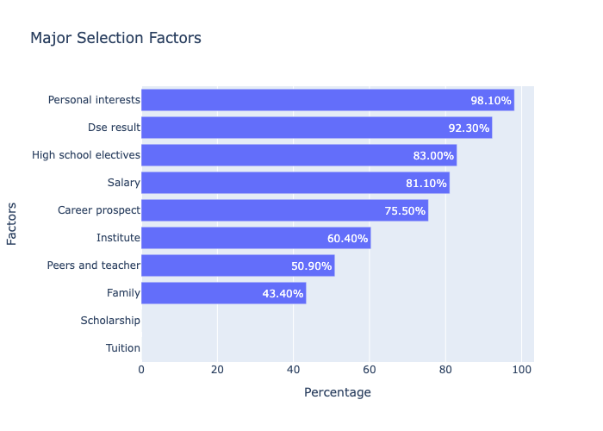

**Occupations Preference (Top 7 Ranking)**

|  |  |
| --- | --- |
| Rank | **Popular Occupations** |
| 1st | Civil |
| 2nd | Start-up Business |
| 3rd | Physical Education |
| 4th | Pharmacy |
| 5th | Psychologist |
| 6th | Biomedical |
| 7th | General Practitioner |

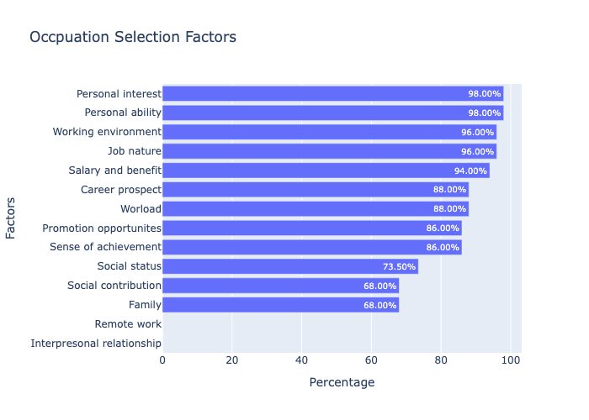

* **Stress Factor**

|  |  |  |  |
| --- | --- | --- | --- |
| **Factor** | **Individual School** | **General** | |
| Personal | 58.3% | | 60.9% |
| External | 41.7% | | 38.9% |

* **Sources**

|  |  |  |  |
| --- | --- | --- | --- |
| **Sources** | **Individual School** | **General** | |
| Parent’s Expectation | 35.8% | | 42.4% |
| Peer Comparison | 22.6% | | 36.4% |
| Tight Study Schedule | 43.4% | | 39.1% |
| Examination Results | 67.9% | | 74.0% |
| Relationships | 18.9% | | 18.2% |
| Own Prospect | 50.9% | | 61.8% |
| Own Expectation | 62.3% | | 61.5% |
| Covid-19 | 3.8% | | 7.4% |
| Long Time Alone | 7.5% | | 8.6% |
| Changing Exam Time | 5.7% | | 7.0% |
| Unstable School Time | 9.4% | | 8.2% |

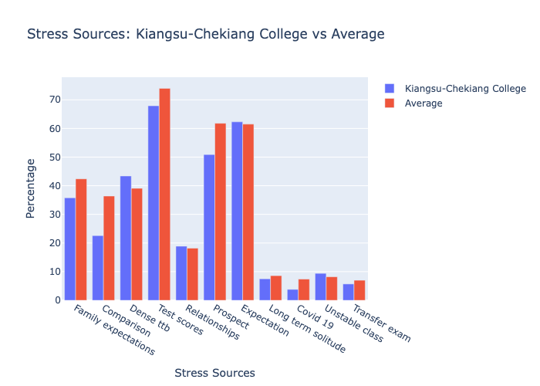

[LLM OUTPUT PLACEHOLDER]

* **Stress Levels**

|  |  |  |  |
| --- | --- | --- | --- |
| **Level** | **Individual School** | **General** | |
| None | 1.9% | | 3.1% |
| Very Low | 5.7% | | 3.0% |
| Low | 11.3% | | 9.7% |
| Moderate | 22.6% | | 27.1% |
| High | 37.7% | | 28.6% |
| Very High | 20.8% | | 28.5% |

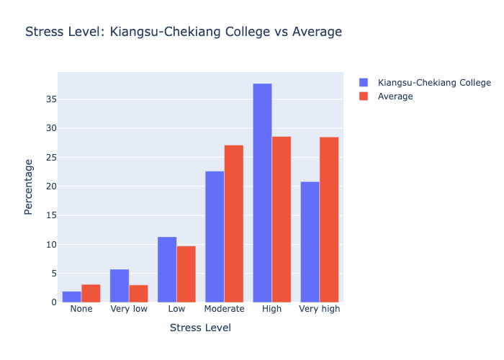

* **Endure Stress**

|  |  |  |  |
| --- | --- | --- | --- |
| **Endure Level** | **Individual School** | **General** | |
| Totally cannot | 63.5% | | 65.0% |
| Mostly cannot | 13.5% | | 11.7% |
| Mostly can | 17.3% | | 17.7% |
| Totally can | 5.8% | | 5.5% |

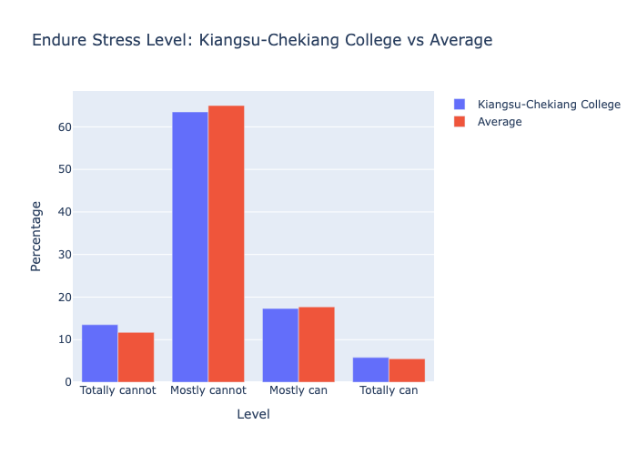

* **Stress Management**

|  |  |  |  |
| --- | --- | --- | --- |
| **Method** | **Individual School** | **General** | |
| Do Exercise | 22.6% | | 28.6% |
| Communicate with Family | 13.2% | | 16.4% |
| Communicate with Friends | 43.4% | | 39.5% |
| School Counsellor | 5.7% | | 5.5% |
| Reschedule Timetable | 9.4% | | 10.1% |
| Sleep | 54.7% | | 41.0% |
| Computer Games | 62.3% | | 64.2% |
| Listen to Music | 60.4% | | 62.3% |
| No Idea | 13.2% | | 11.3% |

